Insert School Logo

Semester Two

Examination 2019

Question/Answer booklet

MATHEMATICS
SPECIALIST UNITS 3 & 4

Section Two:
Calculator-assumed

Student Name: _____________________________________

Teacher’s Name: _____________________________________

Time allowed for this section
Reading time before commencing work: ten minutes
Working time for paper: one hundred minutes

Material required/recommended for this section

To be provided by the supervisor
This Question/Answer booklet
Formula Sheet (retained from Section One)

To be provided by the candidate
Standard items: pens (blue/black preferred), pencils (including coloured), sharpener, correction tape/fluid, erasers, ruler, highlighters

Special Items: drawing instruments, templates, notes on two unfolded sheets of A4 paper, and up to three calculators approved for use in the WACE examinations.

Important note to candidates
No other items may be taken into the examination room. It is your responsibility to ensure that you do not have any unauthorised notes or other items of a non-personal nature in the examination room. If you have any unauthorised material with you, hand it to the supervisor before reading any further.

Structure of this paper

 | Number of questions available | Number of questions to be attempted | Working time (minutes) | Marks available | Percentage of exam
Section One  Calculator—free | 7 | 7 | 50 | 53 | 35
Section Two  Calculator—assumed | 12 | 12 | 100 | 97 | 65
 |  |  |  |  | 100

Instructions to candidates

- The rules for the conduct of Western Australian external examinations are detailed in the
Year 12 Information Handbook 2019. Sitting this examination implies that you agree to abide by these rules.

- Answer the questions according to the following instructions.

Show all your working clearly. Your working should be in sufficient detail to allow your
answers to be checked readily and for marks to be awarded for reasoning. Incorrect answers given without supporting reasoning cannot be allocated any marks. For any question or part question worth more than two marks, valid working or justification is required to receive full marks. If you repeat an answer to any question, ensure that you cancel the answer you do not wish to have marked.

It is recommended that you do not use pencil, except in diagrams.

- You must be careful to confine your responses to the specific questions asked and to follow any instructions that are specific to a particular question.

- Spare pages are included at the end of this booklet. They can be used for planning your responses and/or as additional space if required to continue an answer.
- Planning: If you use the spare pages for planning, indicate this clearly at the top of the page.
- Continuing an answer: If you need to use the space to continue an answer, indicate in the original answer space where the answer is continued, i.e. give the page number. Fill in the number of the question that you are continuing to answer at the top of the page.

- The Formula Sheet is not handed in with your Question/Answer Booklet.

Section Two: Calculator–assumed 65% (97 marks)

This section has twelve (12) questions. Attempt all questions. Write your answers in the spaces
provided.

Working time: 100 minutes

Question 8 (5 marks)

The complex number $z$ satisfies the condition $\left|z+2-2i\right|=\sqrt{2}$ as shown below.
Using exact values, determine both the minimum and maximum values of $\left|z\right|$ and $\arg\left(z\right)$. (5 marks)

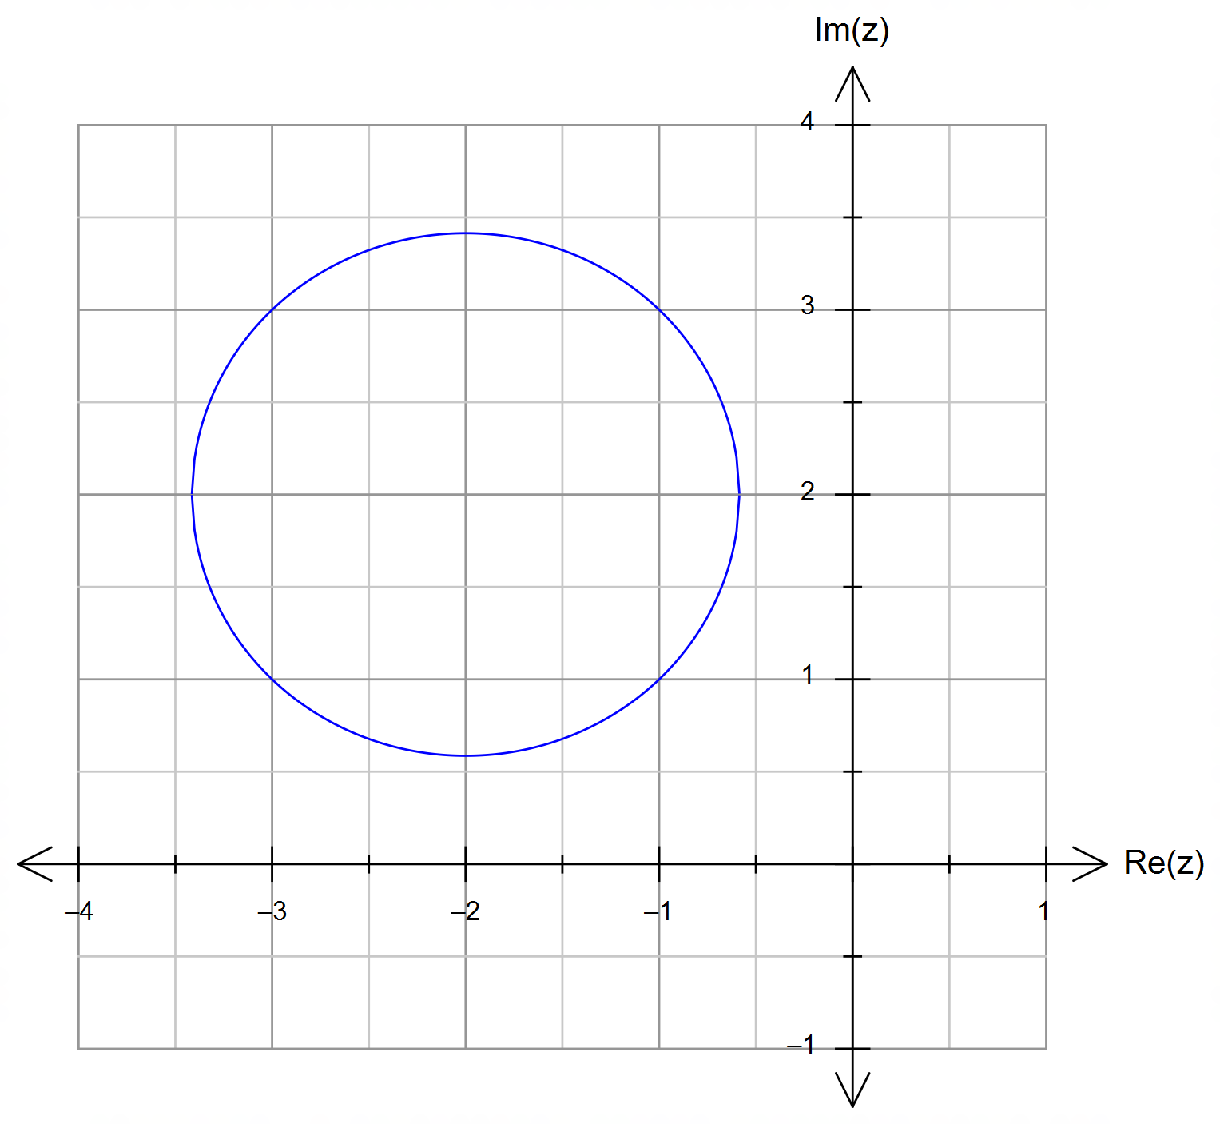

Question 9 (6 marks)

The “Red CAT” bus runs to an approximate schedule of 10 minutes between busses in the city centre.
The time $T$ in minutes that models the time interval between two buses (i.e. the time it takes for one bus to arrive after another one has departed) is modelled by a uniform distribution where $0≤T≤20$.
The population mean is $μ\left(T\right)=10$ minutes and the population variance is $σ^{2}\left(T\right)=300$.

A sample of 30 bus intervals is taken and the sample mean is $\overline{T}$ calculated.

(a) Determine $P\left(5≤\overline{T}≤15\right)$ correct to two (2) decimal places. (3 marks)

(b) If a large number of samples is taken, each with 30 bus interval measurements, sketch the likely
distribution of the sample mean $\overline{T}$. Indicate in your diagram the calculation from part (a).

(3 marks)

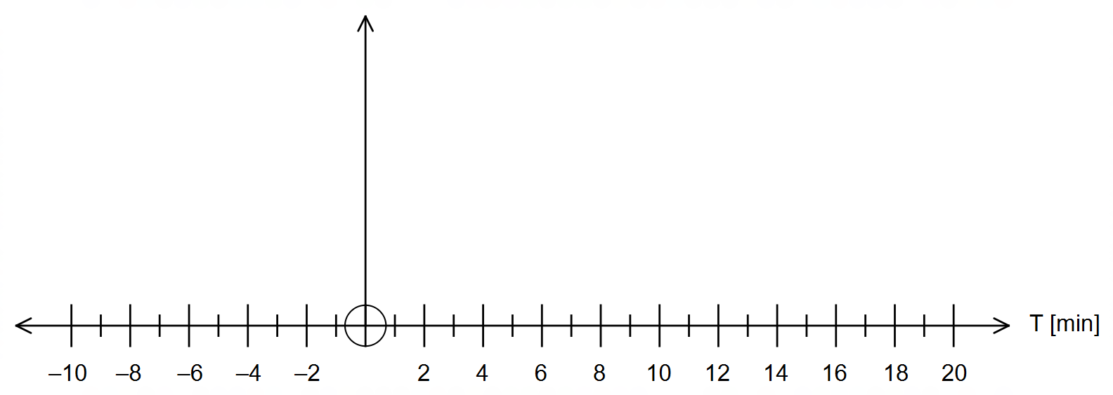

Question 10 (6 marks)

The graph of $f\left(x\right)=a\left|x+b\right|+c$ is shown below.
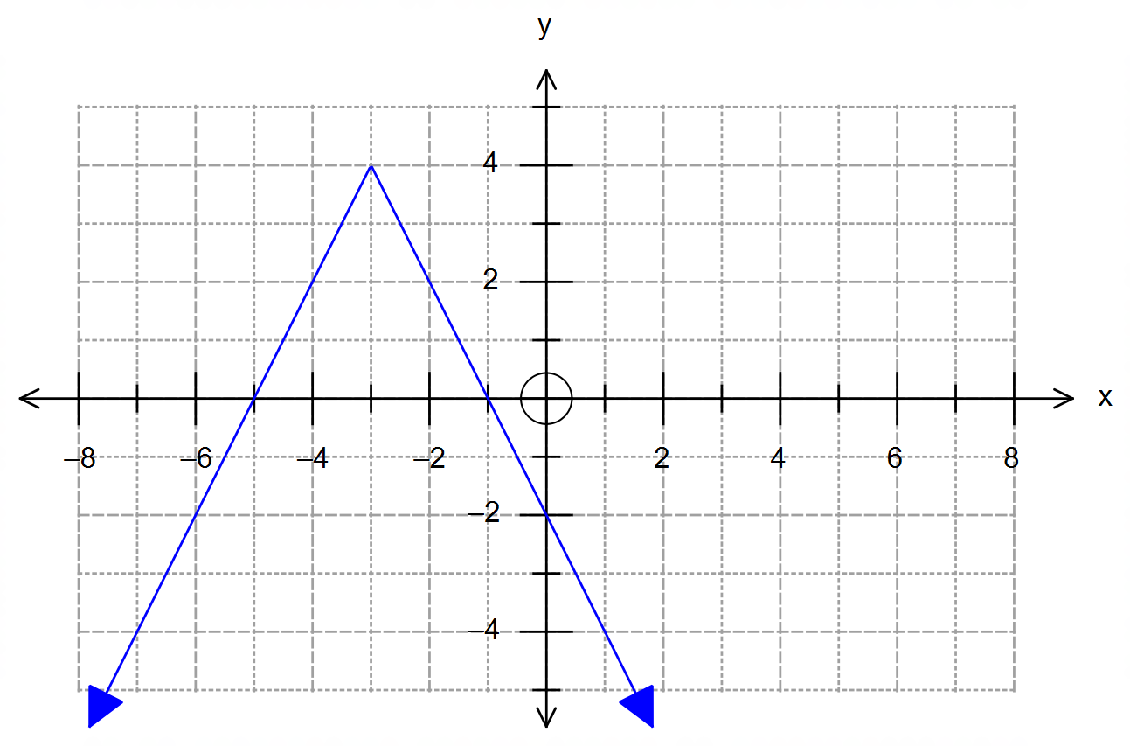

(a) State the value of the constants $a, b$ and $c$. (3 marks)

(b) Determine the value(s) of the constant $d$ in the equation $f\left(-\left|x\right|\right)=d$ so that this
equation has exactly 4 solutions. Justify your answer. (3 marks)

Question 11 (13 marks)

Anti-Ballistic Missiles (ABMs) are used to take down incoming hostile missiles and protect a particular region from enemy attack. An incoming hostile missile is detected at $120i-80j+40k$ km from a monitoring station at O, and it is moving towards its target with a velocity of $2i+j-k$ kms⁻¹.
Round all answers correct to two (2) decimal places where appropriate.

(a) How long after being detected will the incoming hostile missile strike its target on the ground,
and how far from the monitoring station does this occur?
(4 marks)

An ABM is deployed immediately after the hostile missile was detected, and it is launched from a missile silo located at $20i+160j$ km relative to the monitoring station.

(b) Determine the speed that the ABM should have if it is to collide with the hostile missile
at a height of 10 km above level ground.
(4 marks)

(Question 11 – Continued)

The ABM was actually launched with a velocity of $4.6i-5.25j+0.042k$ kms⁻¹.

(c) Determine whether the ABM intercepts the hostile missile.
If it does, then state the time elapsed since it was launched and the altitude at which it occurs.
If it does not, then determine the closest distance between the ABM and the hostile missile, and the time elapsed since it was launched for this to occur.

(5 marks)

Question 12 (7 marks)

The slope field shown below is given by $\frac{dy}{dx}=\frac{1}{2x+2}$ with $x≠-1$.

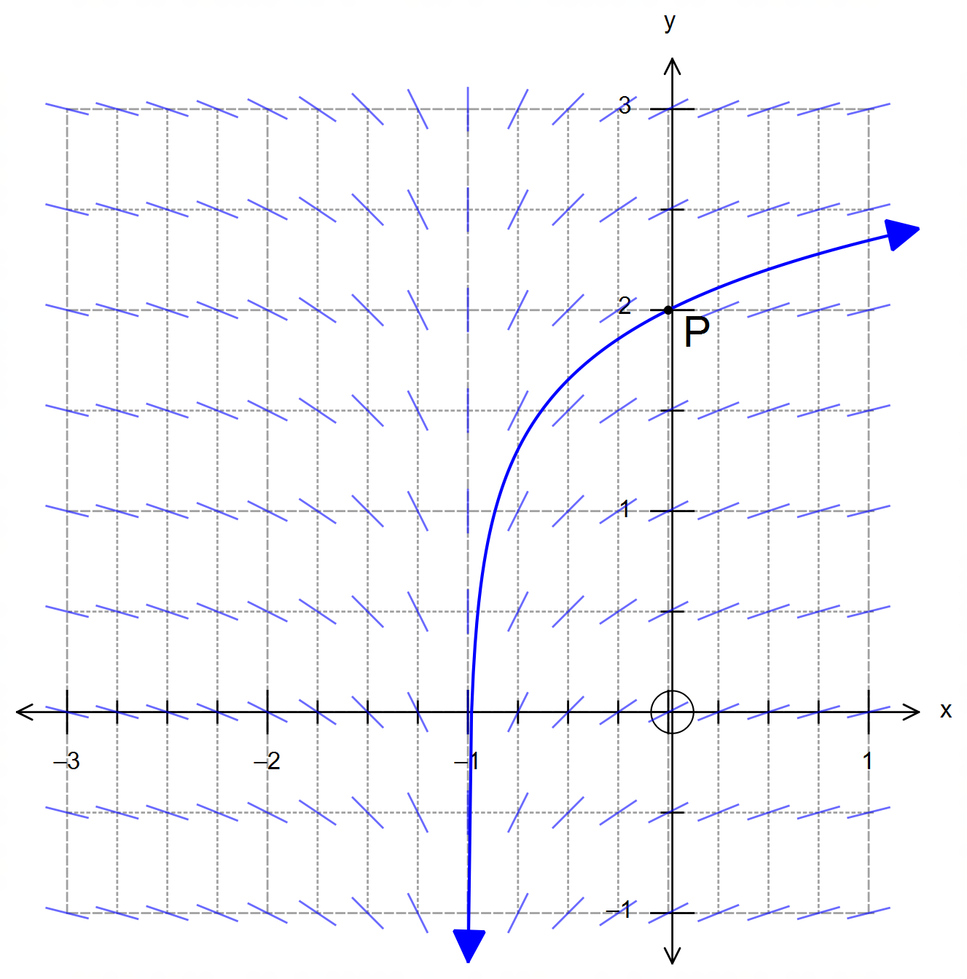

(a) Determine the value of the slope field at the point $P\left(0, 2\right)$ shown. (2 marks)

(b) Explain the behaviour of the slope field along the line $x+1=0$. (1 mark)

(Question 12 – Continued)

(c) Determine the equation of the solution shown that passes through $P\left(0, 2\right)$. (4 marks)

Question 13 (11 marks)

The lifetime of antibiotics in the bloodstream of a patient is believed to be distributed as a logarithmic random variable, with mean $μ=8$ hours and a standard deviation of $σ=8$ hours.

A random sample of the bloodwork of $40$ patients is selected to analyse the speed at which the human body metabolises a particular type of antibiotic that is being trialled. The variable $\overline{X}$ represents the mean lifetime of the antibiotic in the bloodstream for these $40$ patients.

(a) State the distribution of the sample mean lifetime $\overline{X}$. Justify your answer. (3 marks)

(b) Determine the probability that the sample mean lifetime is between $5$ and $11$ hours. (2 marks)

Kathryn, the chief doctor in charge of the study, suggests that the lifetimes may not be logarithmically distributed, and that this alternative distribution will still have a mean of $μ=8$ hours and a standard deviation of $σ=8$ hours.

(c) If Kathryn is correct, will your answer to (b) change? Explain your answer. (2 marks)

(Question 13 – Continued)

A different random sample of size $n$ of the bloodwork of patients was selected.
Repeated sampling of samples of size $n$ shows that there is a $5\%$ chance of obtaining a sample mean greater than $10$ hours.

(d) Determine the value of $n$. (4 marks)

Question 14 (8 marks)

(a) (i) Determine $\frac{d}{dx}\left(x\cos{x}\right)$. (1 mark)

(ii) Using your answer in (i) show that:

$$\int_{0}^{π}{x\sin{x}dx}=π$$
(3 marks)

(Question 14 – Continued)

(b) Use partial fractions to show that:

$$\int{\frac{3}{x^{2}-x-2}dx}=\ln\left|\frac{x-2}{x+1}\right|+C$$
(4 marks)

Question 15 (7 marks)

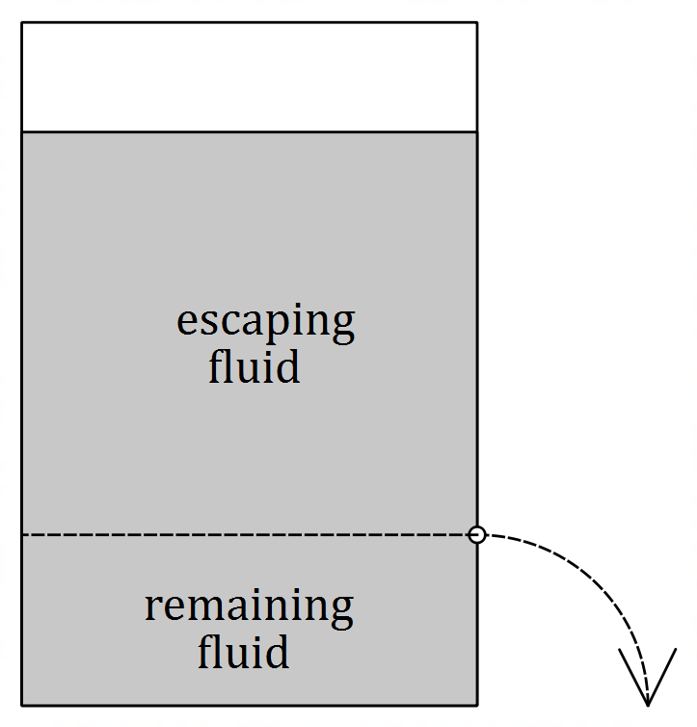The diagram represents a container full of fluid that is punctured on the side. The fluid above the puncture line escapes due to pressure and gravity while the fluid below the line remains in the container.

The rate at which the fluid escapes is proportional to the amount of fluid left in the container, which can be modelled by the differential equation:

$$\frac{dQ}{dt}=k\left(100-Q\right)$$

where $Q$ represents the amount of fluid left in litres and $t$ is the time in minutes since the fluid began to leak.

(a) Use calculus to clearly show that the solution to this differential equation is given by:

$$Q\left(t\right)=A e^{-kt}+100$$
(3 marks)

(Question 15 – Continued)

The container originally holds $900$ litres of fluid and it takes $2.5$ hours for half of the fluid to escape.

(b) How much time in total, correct to the nearest minute, does it take for the leak to stop?
(4 marks)

Question 16 (7 marks)

A scientific experiment measures the total bacteria present per hour over a few days.
The graph below represents the amount of bacteria $B(t)$ present for $t$ hours.
Two particular measurements are provided for $t=15$ hours and $t=25$ hours.

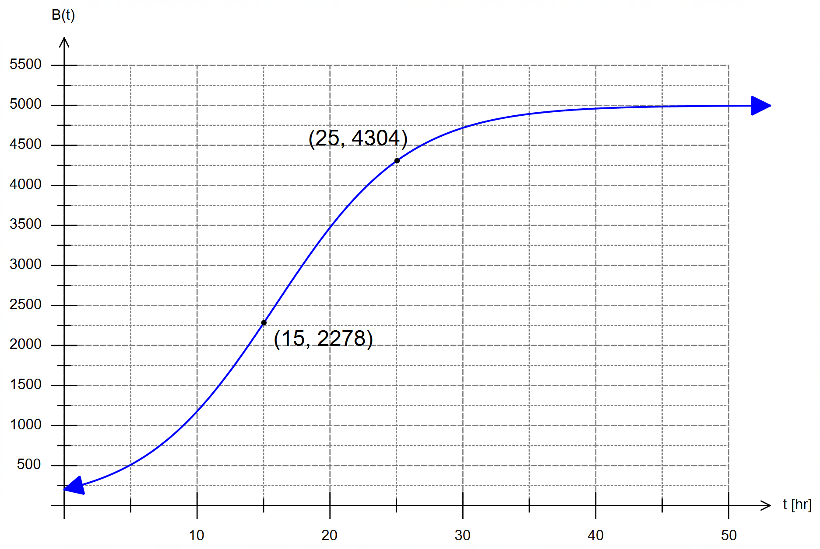

(a) Suggest a differential equation that would model $B\left(t\right)$, the number of bacteria present
per hour. (1 mark)

(Question 16 – Continued)

(b) Determine the solution $B\left(t\right)$ to the differential equation in (a). (4 marks)

(c) How long it would take for the bacteria to reach its maximum capacity? (2 marks)

Question 17 (9 marks)

(a) The graph shows the function $g\left(x\right)$ for the domain $-5≤x<3$.
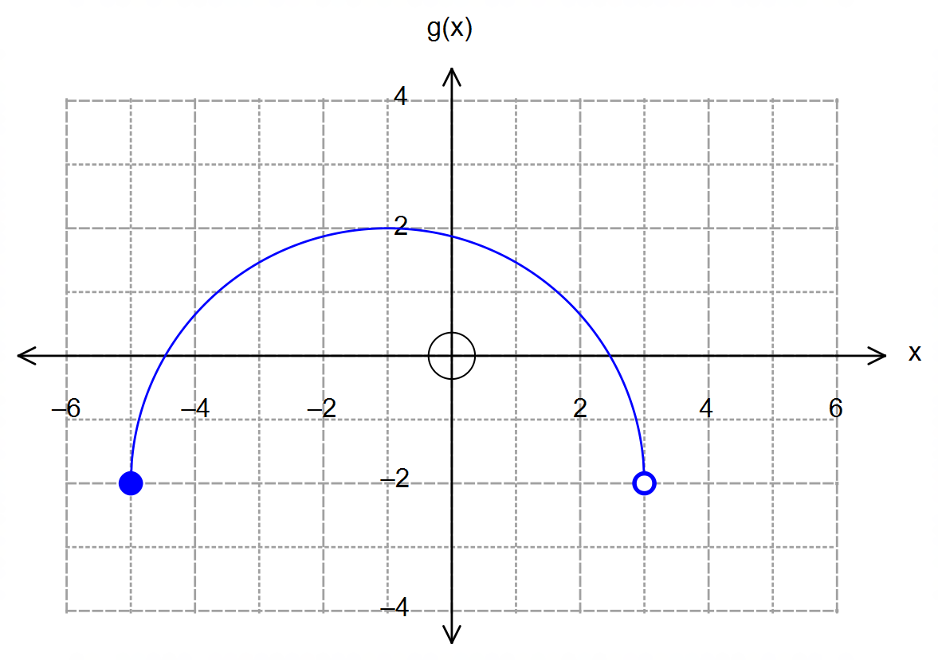

Sketch each of the following variations on $g\left(x\right)$ on the axes provided.

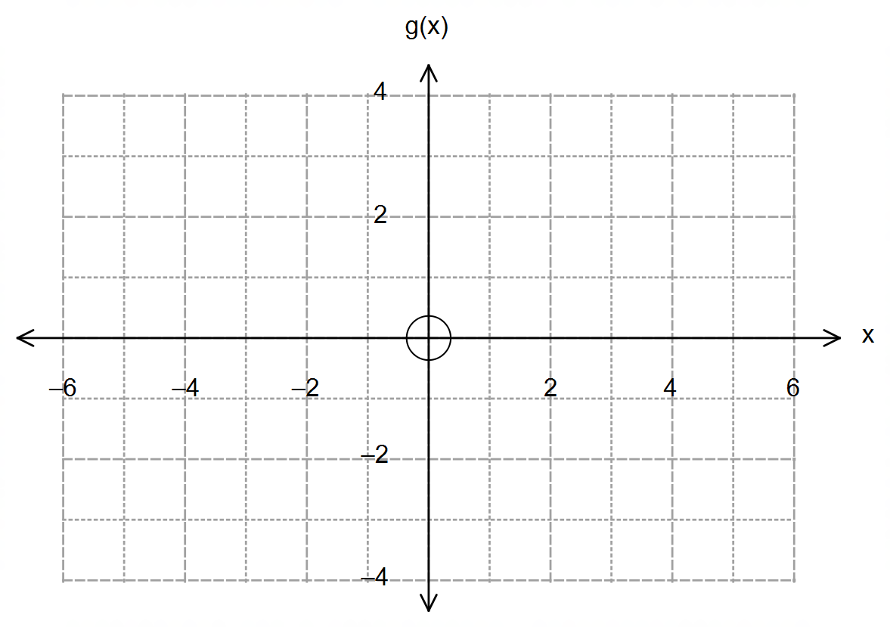

(i) $\left|g\left(\left|x\right|\right)\right|$ (2 marks)

 (ii) $\frac{1}{g\left(x\right)}$ (3 marks)

(Question 17 – Continued)

(b) The functions $f\left(x\right)=4-4\sqrt{x-1}$ and $h\left(x\right)=\frac{1}{{\left(4-x\right)}^{2}}$ are defined for their natural domain.

(i) Determine the function $h∘f\left(x\right)$. (1 mark)

(ii) Determine the restrictions on $f\left(x\right)$ so that $h∘f\left(x\right)$ exists, and hence state its
corresponding range. (3 marks)

Question 18 (9 marks)

A toy drone is programmed to fly on a path described by the equation below, where $\left|r\right|$ is in metres
and $t$ is in seconds.

$$r=4\left(\begin{matrix}\cos{t}+\cos\left(2t\right) \\ \sin{t}-\sin\left(2t\right)\end{matrix}\right)$$

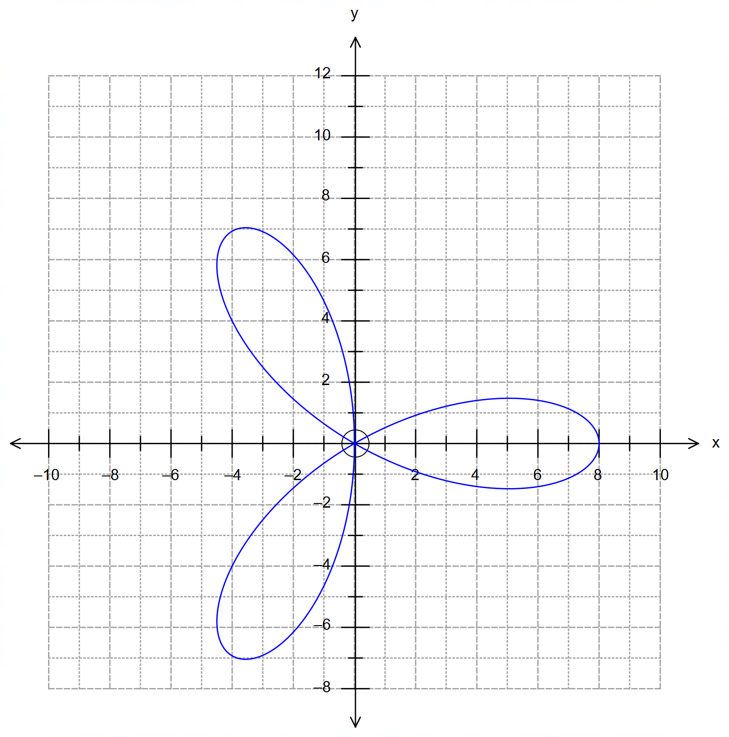

(a) State the time it takes for the drone to complete a full cycle. (1 mark)

(Question 18 – Continued)

(b) Determine the position and velocity of the drone for $t=\frac{π}{2}$ seconds.
Draw these vectors on the same grid above. (5 marks)

It can be shown that the speed of the drone is given by $\left|v\right|=4\sqrt{5+4\sin\left(3t\right)}$.

(c) State the maximum speed of the toy drone and the location where this first occurs. (3 marks)

Question 19 (9 marks)

(a) The diagram shows the area bounded by the curve $y=\frac{1}{\tan\left(x+\frac{π}{6}\right)}$ and the x and y axes.
Show that the exact value of the area shaded is $\ln{2}$. (5 marks)

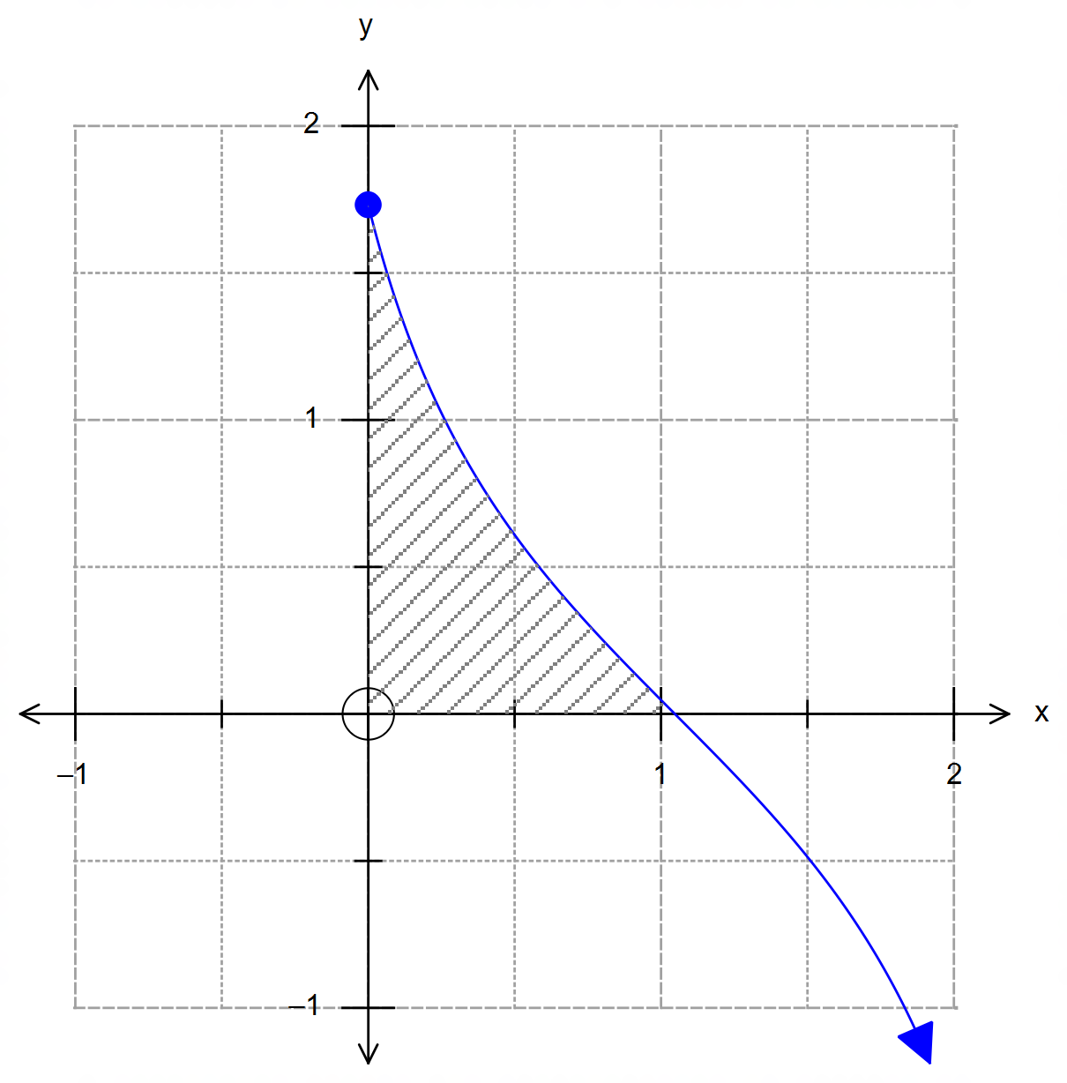

(Question 19 – Continued)

(b) Consider the region shown, which is bounded by the line $y=\frac{r}{h}x$, the x-axis and $0≤x≤h$,
with $x, h∈R, r>0$ and $h>0$.
When this region is rotated over the x-axis it gives a cone of base radius $r$ and height $h$.

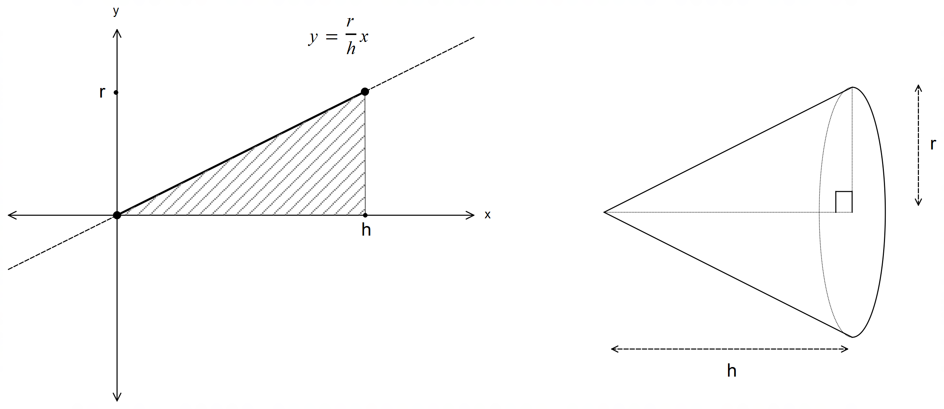

Use calculus to prove that the volume of a cone is given by $\frac{π}{3}r^{2}h$. (4 marks)

End of questions
Additional working space

Question number(s): ……………………

